Date: 01 / December / 2022

**Subject: Project Acceptance Certificate**

**TO WHOMSOEVER IT MAY CONCERN**

This is to certify that **MS REENA J (REG NO: 2101222078018)** Student of **M.SC (Computer Science)** of **Sri Sankara arts and science college** has accepted her project work from **02 December 2022 to 09 March 2023.**

**Domain:** Python

**Title:** **Twitter Sentiment to Detect Hate Speech Using Machine Learning Algorithm Analysis.**

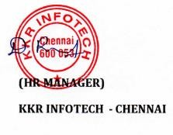Thank you for Engaging KKR INFOTECHs